Report from CBS Lead Centres for GCOS – Region VII

- Performances of GSN stations in region VII responsible area.
(Description of performance on table 1)

Table 1. Performance of GSN stations in 2016
Country | number of stations | CA | CC | CT | CR | Index
Antarctica | 42 | 0.94

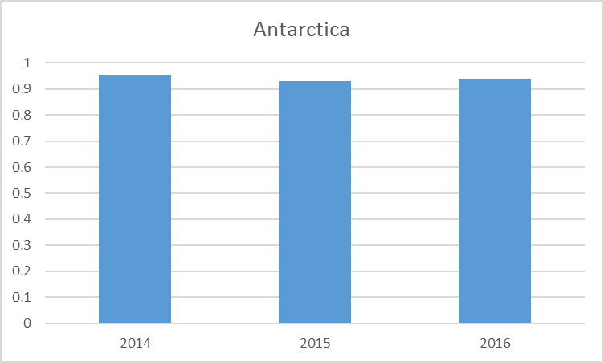
Figure 1 Performance of GSN stations for three years

- Activities of CBSLC in region VII
  - Antarctica
Once again this year the percentage of CLIMAT messages from the Antarctic was in around 95%. This is due to the missing observations being created at the British Antarctic Survey if more than 90% of the main synoptic hours were available on the GTS.

If incorrectly coded CLIMAT Messages were identified then either the national operator is contacted and they were asked to re-send them or the formatting error is corrected and the CLIMAT message resent.

Differences are seen between the monitoring at BAS and at other centers as some of the CLIMAT messages come out after the 21st of the month. These are always the automatic weather stations (AWS) and it is due to there been a delay in the data arriving but this issue is being worked on an now the messages are in most month sent before the 20th of the month. The CLIMAT messages from the manned stations are usually sent by the 5th day of the month.

The synoptic observations are monitored on a daily basis and if a station has not transmitted data for more than 5 days then the national operator is contacted to see if the issue can be resolved.

Issues

Mount Siple AWS (89327) is now considered to be dead and there are no plans to replace the station for logistical reasons so this should be removed from the GSN list.

Dome C II (89828) does not function during the winter due to battery problem, this station is within a few KM of Concordia station (89625) which is also a GSN station and so Dome C II should be removed from the GSN list.

It was noticed in January 2017 that the TTAA part of the radiosonde flight from McMurdo (89664) was appearing on the GTS as a NIL message. They were being transmitted correctly from Antarctica but then being retransmitted as NIL. This issue has now been resolved by the UK Met Office accessing them from the Melbourne hub and then retransmitting the correct message to BAS.

Online Resources

Online resources to allow people to view their data from Antarctica can be found at https://legacy.bas.ac.uk/met/jds/met/SCAR_oma.htm
Information where sensor failures have been detected at stations transmitting on the GTS can be found at:
https://legacy.bas.ac.uk/met/READER/GCOS/PERCENTAGES/sensor_status_suspect.html

