Report from CBS Lead Centres for GCOS – Region VII

- Performances of GSN stations in region VII responsible area.
(Description of performance on table 1)

Table 1. Performance of GSN stations in 2017
Country | number of stations | CA | CC | CT | CR | Index
Antarctica | 42 | 0.95

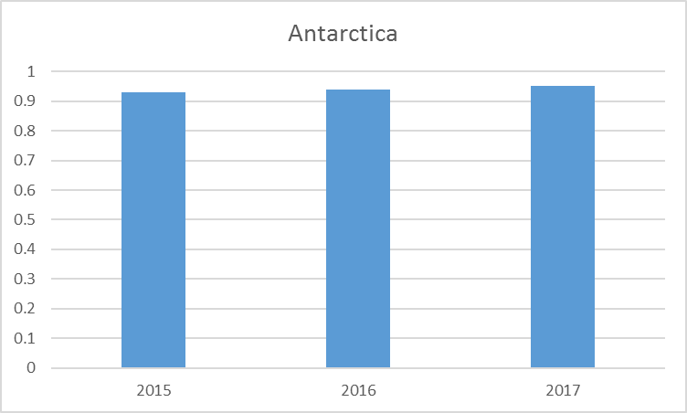
Figure 1 Performance of GSN stations for three years

- Activities of CBSLC in region VII
  - Antarctica
Once again this year the percentage of CLIMAT messages from the Antarctic was in around 95%. This is due to the missing observations being created at the British Antarctic Survey if more than 90% of the main synoptic hours were available on the GTS.

If incorrectly coded CLIMAT Messages were identified then either the national operator is contacted and they were asked to re-send them or the formatting error is corrected and the CLIMAT message resent.

Differences are seen between the monitoring at BAS and at other centers as some of the CLIMAT messages come out after the 21st of the month. These are always the automatic weather stations (AWS) and it is due to there been a delay in the data arriving but this issue is being worked on an now the messages are in most month sent before the 20th of the month. The CLIMAT messages from the manned stations are usually sent by the 5th day of the month.

The synoptic observations are monitored on a daily basis and if a station has not transmitted data for more than 5 days then the national operator is contacted to see if the issue can be resolved.

Issues

Halley station was closed during the 2017 winter (and is again closed for the 2018 winter) radiosonde ascents stopped on the 12th February 2017 and resumed again on the 7th December 2017. The synoptic observations continued from an AWS that was setup at the site.

Synoptic observations stopped appearing on the GTS on the 29th December 2016 from the Uruguayan station Dinamet (89054) this is an ongoing issue.

Bonaparte Point AWS (89289) was removed on April 26th 2017.

There was a gap in the synoptic observations from Limbert (89257) and Larsen (89262) between May and October 2017 due to technical issues with the AWS.

Synoptic observations stopped appearing on the GTS in May 2017 from Kohnen EP9 AWS (89057).

Synoptic observations from Molodeznaja (89542) started again in August 2017.

Synoptic observations from Druzhnaya 4 (89575) stopped in January 2017 and Leningradskaya (89657) stopped in April 2017.

No data has been available from Thiel Mountains AWS (89087) since January 2017 so BAS have not been able to create synoptic messages for this station.

Online Resources

Online resources to allow people to view their data from Antarctica can be found at https://legacy.bas.ac.uk/met/jds/met/SCAR_oma.htm
Information where sensor failures have been detected at stations transmitting on the GTS can be found at:
https://legacy.bas.ac.uk/met/READER/GCOS/PERCENTAGES/sensor_status_suspect.html

